**Detailed information on the metadata dataset template**

This metadata model has been created with the aim to provide a standardized list of metadata to comprehensively describe in full detail preclinical image datasets.

This list of metadata is intended to be fully descriptive of any image datasets for allowing enough information to ensure as much as possible the repeatability as well as for providing enough information to allow its discovery with specific queries inside a database collecting several image datasets.

The aim is to create a standardized list of metadata for preclinical studies with the application of the FAIR principle: findable, accessible, interoperable and reusable.

It is provided a file Excel providing the most useful information needed to describe a given preclinical imaging dataset, covering several domains, underlined in different colors on the template:

1. **Study design**
2. **Study component**
3. **IVEP (in vivo experimental parameters)**
4. **Experimental procedures**
5. **Image acquisition**
6. **Image data**
7. **Image correlation**
8. **Analysed data**

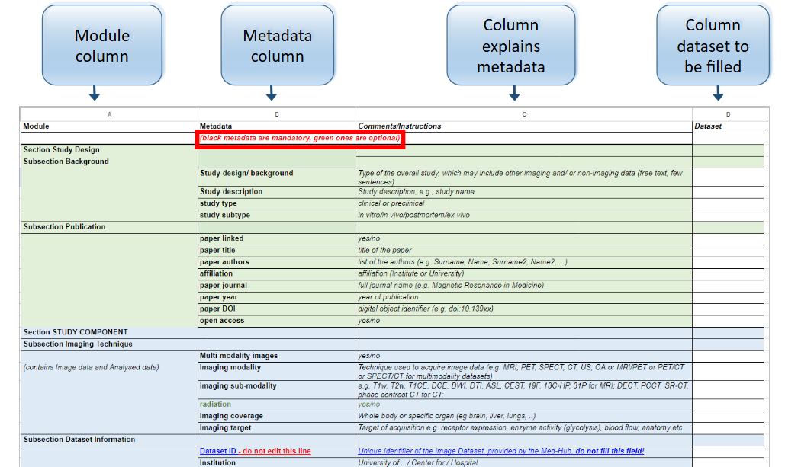

Some of these sections are made up by different subsections, specified in the template. Next to each metadata name is provided a small comment as description of the requested field.

* It is highly recommended to fill as much as possible metadata fields to better describe the dataset.
* If some of the metadata are not applicable to the dataset please leave the corresponding cells empty or tagged N/A.
* If you think that some metadata is missing to properly describe the dataset and the study, please add this information as a comment, in red.
* Metadata in "black" are considered mandatory, those in "green" are optional.
* Please provide the information whether the dataset is public or limited (***Row #42***),
* If there is an associated publication or is in progress (***Row #10***).
* Please include the email of the contact person to whom request additional information/details of the provided metadata (***Row #48***), if needed from our side for the curation of the datasets.

To better provide some information, some metadata will be described shortly.

Regarding the **Data Usage Ontology (DUO)** metadata, you have to read the following table and match the code number of the definition that better describes how your dataset could be shared for you, that describes:

* Data permission (***Row #45***),
* Research-specific restriction (***Row #46***)
* Which type of investigation the dataset is associated with (***Row #47***).

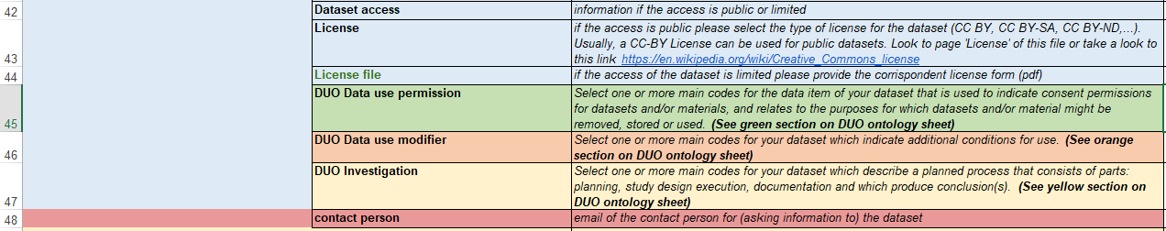

A full description for all the codes is provided here:

|  |  |  |
| --- | --- | --- |
| **DUO ontology codes and terms are a simple set of data use terms most often used or referenced in consent form that include provisions for data sharing.** |  |  |
| **Term** | **Label** | **Description** |
| *DUO:0000001* | *data use permission* | *A data item that is used to indicate consent permissions for datasets and/or materials, and relates to the purposes for which datasets and/or material might be removed, stored or used.* |
| DUO:0000042 | General Research Use | This data use limitation indicates that use is allowed for health/medical/biomedical purposes and other biological research, including the study of population origins or ancestry. |
| DUO:0000004 | no restriction | This consent code primary category indicates there is no restriction on use. |
| DUO:0000006 | health/medical/biomedical research and clinical care | This primary category consent code indicates that use is allowed for health/medical/biomedical purposes; does not include the study of population origins or ancestry. |
| DUO:0000007 | disease-specific research and clinical care | This primary category consent code indicates that use is allowed provided it is related to the specified disease. |
| DUO:0000011 | population origins or ancestry research | This primary category consent code indicates that use of the data is limited to the study of population origins or ancestry. |
|  |  |  |
| *DUO:0000012* | *research-specific restrictions* | *This secondary category consent code indicates that use is limited to studies of a certain research type.* |
| DUO:0000015 | no general methods research | This secondary category consent code indicates that use includes methods development research(e.g., development of software or algorithms) only within the bounds of other use limitations. |
| DUO:0000016 | genetic studies only | This secondary category consent code indicates that use is limited to genetic studies only (i.e., no phenotype-only research). |
| DUO:0000017 | data use modifier | Data use modifiers indicate additional conditions for use. |
| DUO:0000018 | not-for-profit use only | This requirement indicates that use is limited to not-for-profit organizations. |
| DUO:0000019 | publication required | This requirement indicates that requestor agrees to make results of studies using the data available to the larger scientific community. |
| DUO:0000020 | collaboration required | This requirement indicates that the requestor must agree to collaboration with the primary study investigator(s). |
| DUO:0000021 | ethics approval required | This requirement indicates that the requestor must provide documentation of local IRB/ERB approval. |
| DUO:0000022 | geographical restriction | This requirement indicates that use is limited to within a specific geographic region.. |
| DUO:0000024 | publication moratorium | This requirement indicates that requestor agrees not to publish results of studies until a specific date. |
| DUO:0000025 | time limit on use | This requirement indicates that use is approved for a specific number of months. |
| DUO:0000026 | user-specific restriction | This requirement indicates that use is limited to use by approved users. |
| DUO:0000027 | project-specific restriction | This requirement indicates that use is limited to use within an approved project. |
| DUO:0000028 | institution-specific restriction | This requirement indicates that use is limited to use within an approved institution. |
| DUO:0000029 | return to database/resource | This requirement indicates that the requestor must return derived/enriched data to the database/resource. |
| DUO:0000043 | clinical care use | This data use modifier indicates that use is allowed for clinical use and care. |
| DUO:0000044 | population origins or ancestry research prohibited | This data use modifier indicates use for purposes of population, origin, or ancestry research is prohibited. |
| DUO:0000045 | not for profit organisation use only | This data use modifier indicates that use of the data is limited to not-for-profit organizations. |
| DUO:0000046 | non-commercial use only | This data use modifier indicates that use of the data is limited to not-for-profit use. |
|  |  |  |
| *OBI:0000066* | *Investigation* | *a planned process that consists of parts: planning, study design execution, documentation and which produce conclusion(s).* |
| DUO:0000034 | Age category research | Should be paired with the an ontology term representing this population (e.g., xxx). |
| DUO:0000033 | Ancestry research | An investigation concerning ancestry or population origins. |
| DUO:0000037 | Biomedical research | An investigation concerning health, medical, or biomedical research. |
| DUO:0000040 | Disease category research | Biomedical research research concerning specific disease/s |
| DUO:0000039 | Drug development research | Biomedical research concerning drug development. |
| DUO:0000038 | Genetic research | Biomedical research concerning genetics (i.e., the study of genes, genetic variations and heredity). |
| DUO:0000035 | Gender category research | An investigation concerning specific gender categories. |
| DUO:0000031 | Method development | An investigation concerning development of methods, algorithms, software or analytical tools. |
| DUO:0000032 | Population research | An investigation concerning a specific population group. |
| DUO:0000036 | Research control | An investigation concerning use of data as reference or control material. |

for more details click here: <https://www.ncbi.nlm.nih.gov/pmc/articles/PMC8591903/>

Please also make sure to provide which license type should be attributed to your dataset. For more information about the licenses’ types, refer to the table above.

The licence refers to the data collected not to the publication.

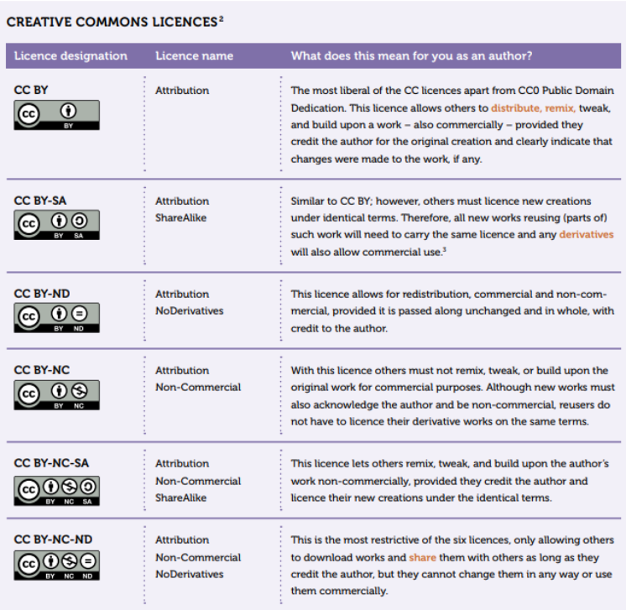

for more details click here: <https://it.wikipedia.org/wiki/Licenze_Creative_Commons>